DEPT. OF ELECTRICAL & ELECTRONICS ENGINEERING

SRM INSTITUTE OF SCIENCE AND TECHNOLOGY, Kattankulathur – 603 203

|  |
| --- |
| Title of Experiment : **1. Verification of Kirchhoff’s Laws** |
| Name of the candidate : PONNURI ANIRUDDHA  Register Number :RA2112704010015  Date of Experiment : MARCH 9Th,2022 |

|  |  |  |  |
| --- | --- | --- | --- |
| Sl.  No. | Marks Split up | Maximum marks  (15) | Marks obtained |
| 1 | Pre Lab questions |  |  |
| 2 | Preparation of observation |  |  |
| 3 | Execution of experiment |  |  |
| 4 | Calculation / Evaluation of Result |  |  |
| 5 | Post Lab questions |  |  |
| **Total** | | **15** |  |

Staff Signature

**PRE LAB QUESTIONS**

**1. Define Ohm’s law.**

**According to Ohm’s Law electric current is directly proportional to voltage under constant temperature. (V = IR)**

**2. State KCL and KVL.**

**KCL:-- It states that in a electric circuit , at any node, at any time, the algebraic sum of all the incoming and outgoing meeting at the node is zero.**

**KVL:--** **In an electric circuit for any of its**

**loop at any time the algebraic sum of all the element voltages around the loop is zero i.e. In a loop the total voltage drop is equal to the total voltage rise.**

**3. Define ideal and practical current and voltage sources.**

**Ideal current sources provide the exact same current to any passive component connected to it.**

**Partial current source may provide a varied current to the components. Voltage source is an active element which provides potential difference.**

**4. What is the difference between active and passive elements?**

**Anything that provides some source is called the active element and components which are dependent on the active elements are called passive elements.**

**5. What is a loop and node?**

**A node is the point of connection between two or more branches. A loop is any closed path in a circuit**

|  |  |
| --- | --- |
| **Experiment No. 1**  **Date:** MARCH 9Th,2022 | **VERIFICATION OF KIRCHOFF’S LAWS** |

**Aim:**

To verify Kirchhoff’s current law and Kirchhoff’s voltage law for the given circuit.

**Apparatus Required:**

|  |  |  |  |
| --- | --- | --- | --- |
| Sl.No. | Apparatus | Range | Quantity |
| 1 | RPS (regulated power supply) | (0-30 V) | 2 |
| 2 | Resistance | 330 Ω, 220 Ω 1kΩ | 6 |
| 3 | Ammeter | (0-30 mA)MC | 3 |
| 4 | Voltmeter | (0-30 V)MC | 3 |
| 5 | Bread Board & Wires | -- | Required |

**Statement:**

**KCL:** The algebraic sum of the currents meeting at a node/junction is equal to zero.

**KVL:** In any closed path / mesh, the algebraic sum of all the voltages is zero.

**Precautions:**

1. Voltage control knob should be kept at minimum position.
2. Current control knob of RPS should be kept at maximum position.

**Procedure for KCL:**

1. Give the connections as per the circuit diagram.
2. Set a particular value of voltage (refer table) in RPS using voltage control knob
3. Note down the corresponding ammeter reading
4. Repeat the same for different voltages

**Procedure for KVL:**

1. Give the connections as per the circuit diagram.
2. Set a particular of voltage (refer table) in RPS.
3. Note all the voltage reading
4. Repeat the same for different voltages

**HARDWARE SETUP:**

**Circuit for KCL verification:**

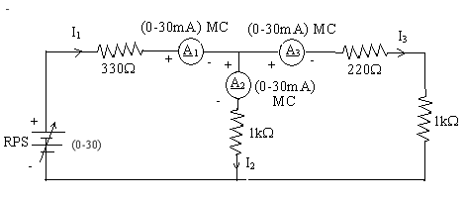

**KCL - Theoretical Values:**

|  |  |  |  |  |  |
| --- | --- | --- | --- | --- | --- |
| **Sl.**  **No.** | **Voltage**  **E** | **Current** | | | **I1 = I2 + I3** |
| **I1** | **I2** | **I3** |
| **Volts** | **mA** | **mA** | **mA** | **mA** |
| 1 | 10 | 11.37 | 6.248 | 5.121 | 22.73 |
| 2 | 20 |  |  |  |  |
| 3 | 25 |  |  |  |  |

**KCL - Practical Values:**

|  |  |  |  |  |  |
| --- | --- | --- | --- | --- | --- |
| **Sl.**  **No.** | **Voltage**  **E** | **Current** | | | **I1 = I2 + I3** |
| **I1** | **I2** | **I3** |
| **Volts** | **mA** | **mA** | **mA** | **mA** |
| 1 | 10 | 11.37 | 6.25 | 5.12 | 22.74 |
| 2 | 20 | 22.74 | 12.5 | 10.24 | 45.48 |
| 3 | 25 | 28.74 | 15.62 | 12.8 | 62.84 |

**Model Calculations:**

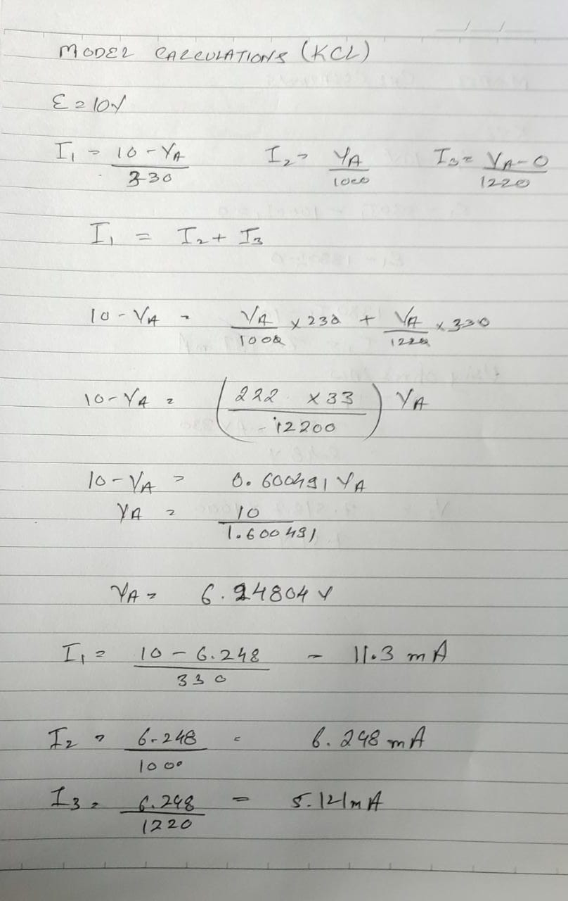

**Circuit for KVL verification:**

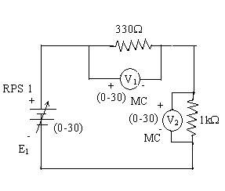

**KVL – Theoretical Values**

|  |  |  |  |  |
| --- | --- | --- | --- | --- |
| **Sl.No.** | **RPS** | **Calculated voltage values** | | **KVL**  **E1 = V1 + V2** |
| **E1** | **V1** | **V2** |
| **V** | **V** | **V** | **V** |
| 1 | 10 |  |  |  |
| 2 | 20 |  |  |  |
| 3 | 25 |  |  |  |

**KVL - Practical Values**

|  |  |  |  |  |
| --- | --- | --- | --- | --- |
| **Sl.No.** | **RPS** | **Voltmeter reading** | | **KVL**  **E1 = V1 + V2** |
| **E1** | **V1** | **V2** |
| **V** | **V** | **V** | **V** |
| 1 | 10 | 2.48 | 7.52 | 10 |
| 2 | 20 | 4.96 | 15.04 | 20 |
| 3 | 25 | 6.2 | 18.8 | 25 |

**Model Calculations:**

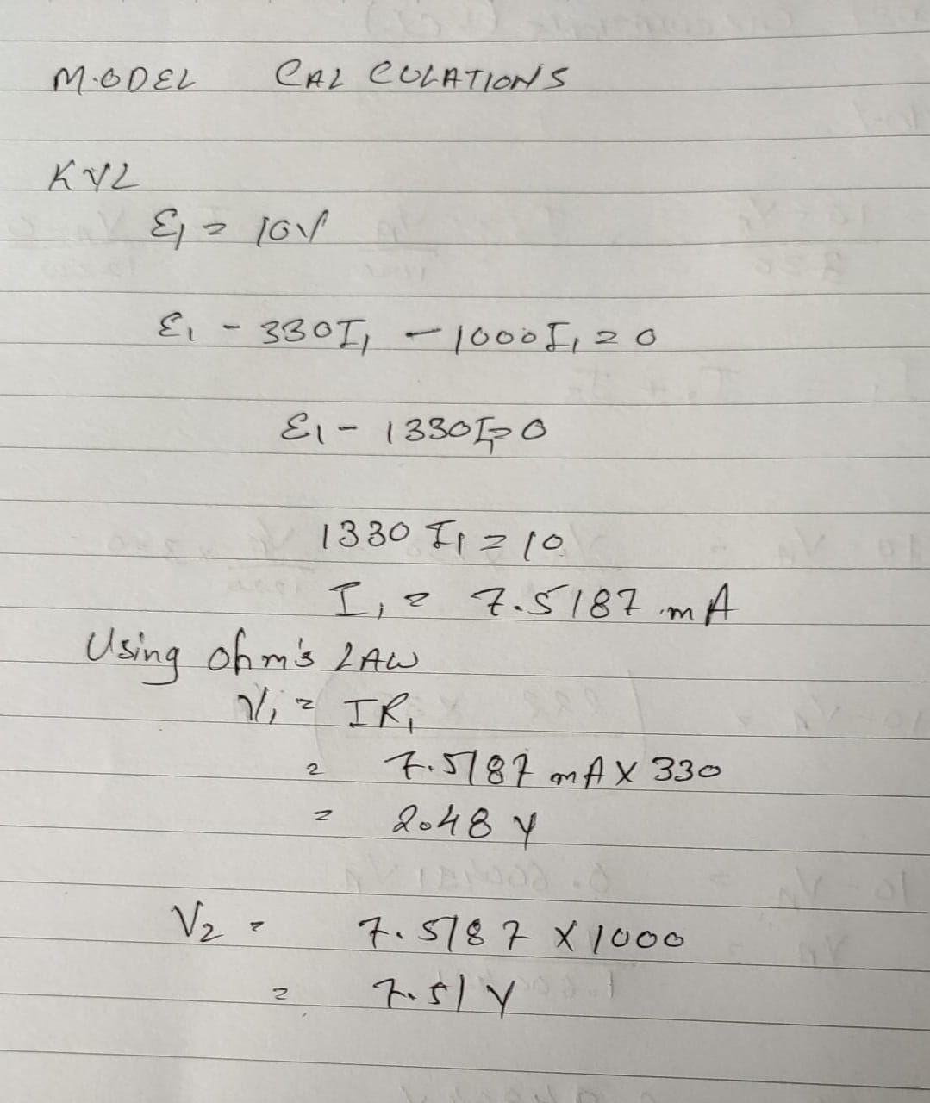

**e- Circuit Simulation outputs:**

**KCL**

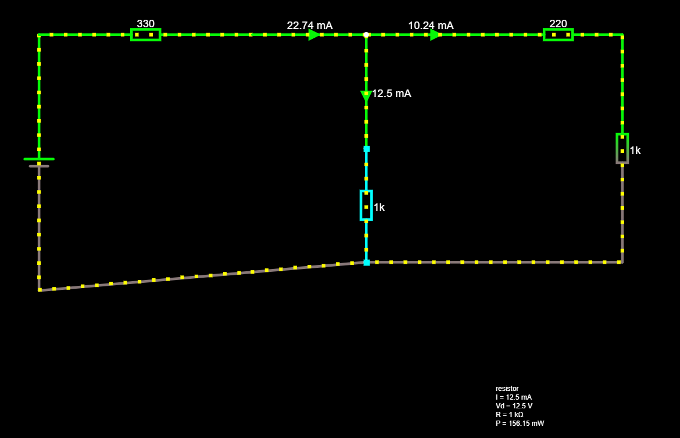

**KVL**

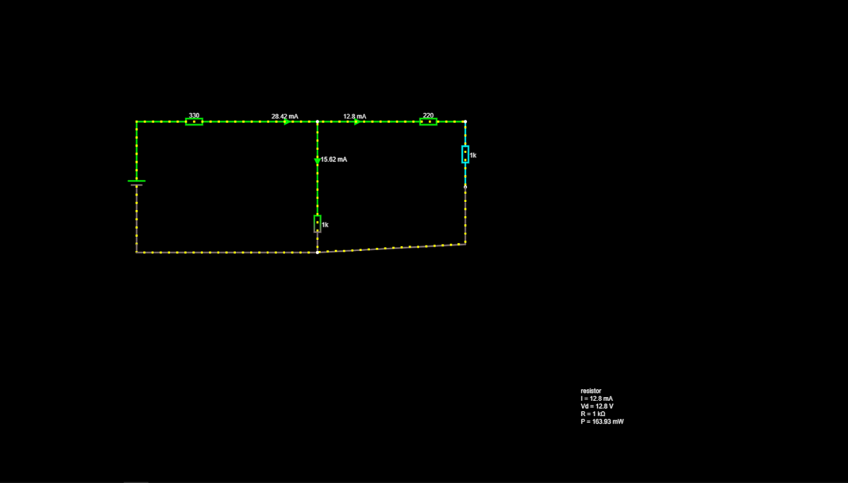

**Result:**

Verified Kirchhoff’s current law and Kirchhoff’s voltage law for the given circuit

**POST LAB QUESTIONS**

1. **Define resistance.**

**Resistance is a measure of the opposition to current flow in an electrical circuit.**

1. **Express the limitations of Ohm’s law?**

**The limitation of ohm’s law is that it is only applicable if constant temperature is maintained in a circuit.**

1. **What is the unit for V, I, R, L and C?**

**V: - It stands for Voltage. Its S.I. unit is “Volts”.**

**I: - It stands for Current. Its S.I. unit is “Ampere”.**

**R: - It stands for Resistor. Its S.I. unit is “Ohm”.**

**L: - It stands for Inductor. Its S.I. unit is “henry”.**

**C: -It stands for charge. Its S.I. unit is “columb”.**

**C: -It stands for capacitor. Its S.I unit is “farad”**

1. **Compare series and parallel circuits**

|  |  |
| --- | --- |
| **Series** | **Parallel** |
| The same amount of current flows through all the components | The current flowing through each component combines to form the current flow through the source. |
| In an electrical circuit, components are arranged in a line | In an electrical circuit, components are arranged parallel to each other |
| When resistors are put in a series circuit, the voltage across each resistor is different even though the current flow is the same through all of them. | When resistors are put in a parallel circuit, the voltage across each of the resistors is the same. Even the polarities are the same |
| If one component breaks down, the whole circuit will burn out. | Other components will function even if one component breaks down, each has its own independent circuit |
| If Vt is the total voltage then it is equal to V1+V2+V3 | If Vt is the total voltage then it is equal to V1=V2=V3 |

1. **What is the difference between series and** **parallel connection of batteries?**

**SERIES CONNECTION OF BATTERIES**

**A set of batteries are said to be connected in series when the positive terminal of one cell is connected to the negative terminal of the succeeding cell.** **The overall emf of the battery is the algebraic sum of all individual cells connected in series.**

**PARALLELL CONNECTION OF BATTERIES**

**A set of batteries are said to be connected in parallel when the positive terminals are connected in a battery, and similarly, negative terminals of these cells are connected. These combinations are referred to as parallel batteries.** **If the emf of each cell is identical, then the emf of the battery combined by n numbers of cells connected in parallel is equal to the emf of each cell.**